**Quantlet Usage Remarks**

# Downloading the whole quantlet set

If you are interested in running (one of) our quantlets, feel free to download the project repository “SPL_OilUS” from GitHub.com . You can do so by accessing the repository and cloning it on your PC or Mac.

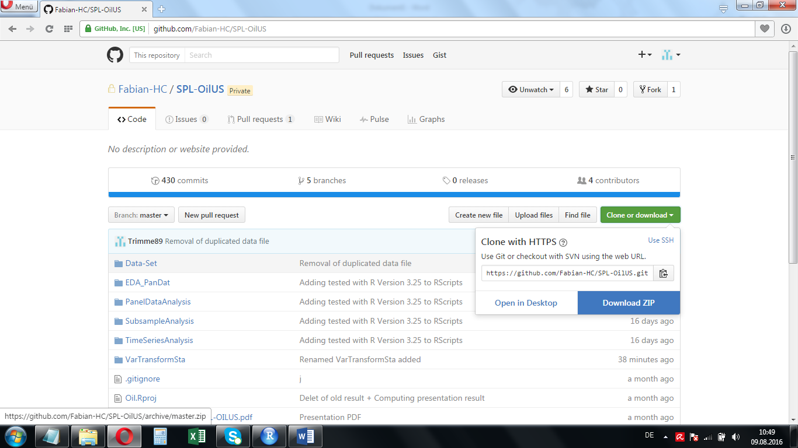

Just go to the top level of the repository, click on the green “Clone or download” button and download the ZIP-file containing the entire repository on your machine.

# Running a specific quantlet on your machine

We suggest you to open the R-code related to your quantlet of interest first. Before running the quantlet, please specify the “Working Directory”. This one has to be the specific quantlet folder stored on your machine. In RStudio, this works the following way:

1. In the menu bar, click “Session”, choose “Set Working Directory” in the dropdown menu and click “Choose Directory …” in the subsequent dropdown menu.

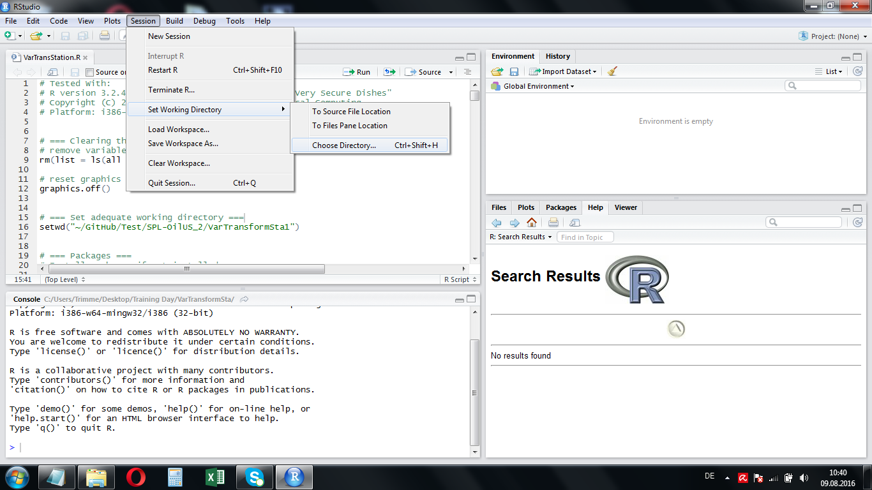There, you can set the specify quantlet directory.

**Other R Versions.**

If you use a ‘basic R version’, e.g. ‘R version 3.2.4 Revised’, please take a look at bullet point N°3.

1. Set the right working directory in the R code

After having chosen the adequate working directory, you see that the line setwd(…) has appeared in the console.   
Copy and paste this line into the quantlet code just below the comment “Set your working directory (here)”.

**ATTENTION  
Please remove the line which stood there previously!**

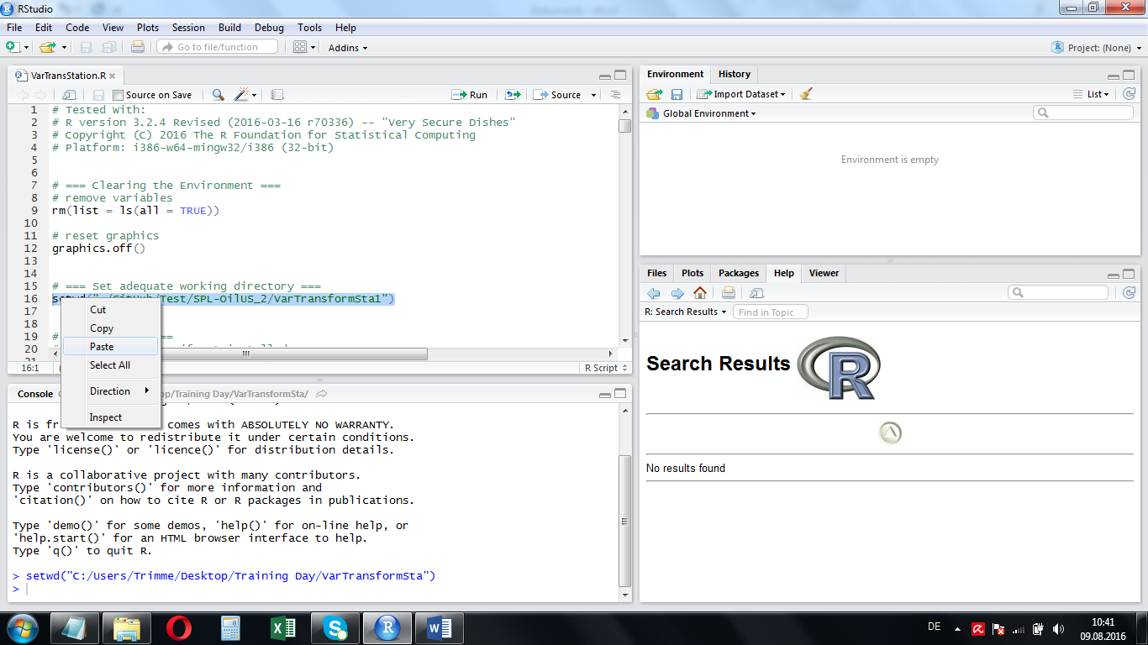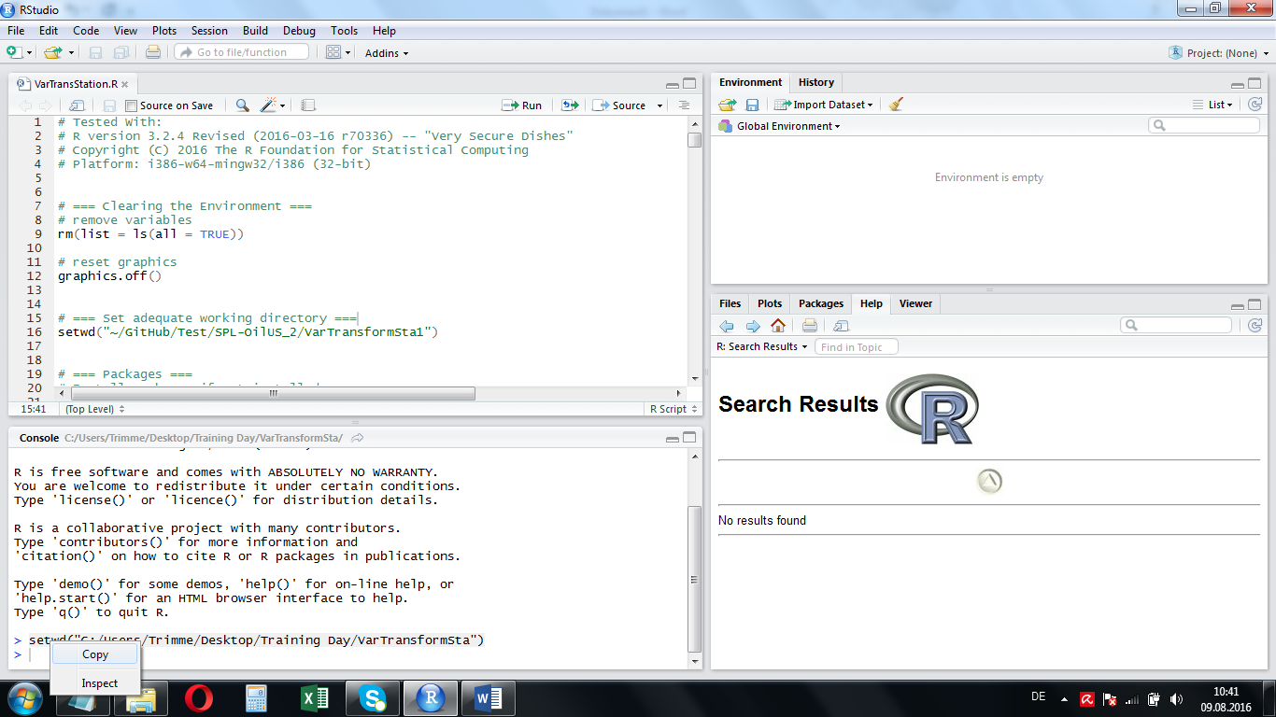

1. Remark on usage with ‘basic R’[1]

If you do not use RStudio, but a ‘basic version’ of R, you can set the working directory performing the following step(s)

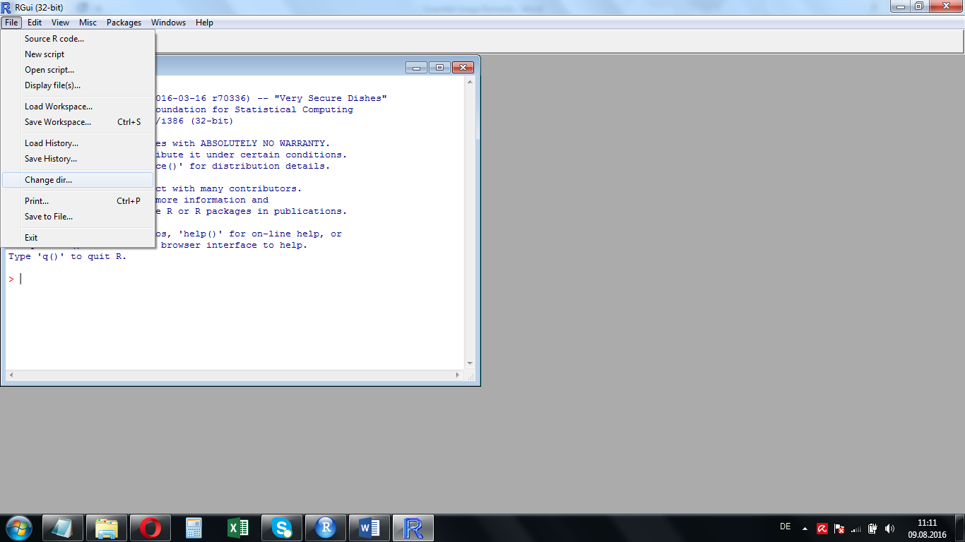Click “File” in the menu bar, choose   
“Change dir …” from the dropdown menu and then set the adequate working directory.

**Next, perform steps specified in bullet point number 2.**

1. We used R version 3.2.4 Revised